Adjective Clause

✅ Definition:
# Source: Chatgpt (GPT-4-turbo) at [7/29/2025]
An adjective clause is a dependent clause that modifies a noun or pronoun.
It tells which one, what kind, or gives more information about the noun.
It usually begins with a relative pronoun (who, whom, whose, which, that) or a relative adverb (when, where, why).

🧩 Structure:
# Source: Chatgpt (GPT-4-turbo) at [7/29/2025]
Relative Pronoun/Adverb + Subject + Verb
OR
Relative Pronoun/Adverb + Verb

🎯 What It Modifies:
# Source: Chatgpt (GPT-4-turbo) at [7/29/2025]
An adjective clause describes a noun in the main (independent) clause.

✏️ Examples:
# Source: Chatgpt (GPT-4-turbo) at [7/29/2025]
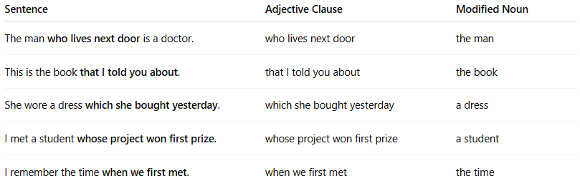
Sentence | Adjective Clause | Modified Noun
The man who lives next door is a doctor. | who lives next door | the man
This is the book that I told you about. | that I told you about | the book
She wore a dress which she bought yesterday. | which she bought yesterday | a dress
I met a student whose project won first prize. | whose project won first prize | a student
I remember the time when we first met. | when we first met | the time

🔍 Common Relative Pronouns & Adverbs:
# Source: Chatgpt (GPT-4-turbo) at [7/29/2025]
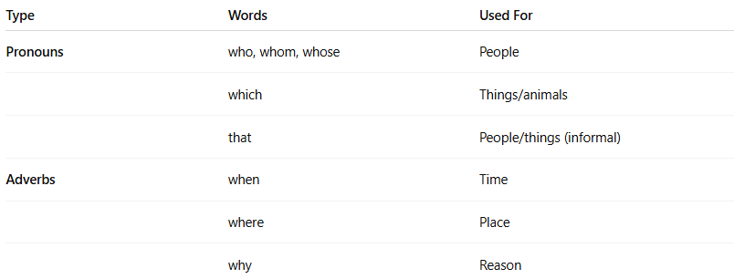

Type | Words | Used For
Pronouns | who, whom, whose | People
 | which | Things/animals
 | that | People/things (informal)
Adverbs | when | Time
 | where | Place
 | why | Reason

🔄 Restrictive vs. Non-restrictive:
# Source: Chatgpt (GPT-4-turbo) at [7/29/2025]
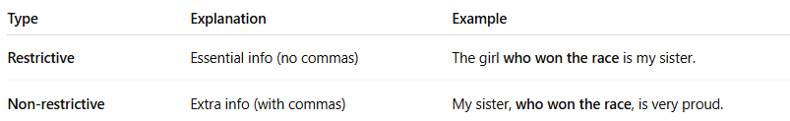

Type | Explanation | Example
Restrictive | Essential info (no commas) | The girl who won the race is my sister.
Non-restrictive | Extra info (with commas) | My sister, who won the race, is very proud.

❗ Note on Omission:
# Source: Chatgpt (GPT-4-turbo) at [7/29/2025]
Sometimes the relative pronoun can be omitted if it's the object of the clause:
- The book (that) I read was amazing. ✅
- The man (who) you met is my teacher. ✅

🧠 Quick Practice – Find the adjective clause:
# Source: Chatgpt (GPT-4-turbo) at [7/29/2025]
- The car that she bought is red.
- I know a place where we can hide.
- The teacher, who loves music, plays guitar in a band.
Answers:
- that she bought → modifies car
- where we can hide → modifies place
- who loves music → modifies teacher

